Alphaslider

* Click slightly above the letter J in the top slider and notice how the thumb jumps to the position your mouse was in.
* Notice the black line in the middle of the thumb. This divides the thumb in half.
* When you click in the **top** half of the thumb and drag you move 10 items at a time. IE: go from item 1 to 11 to 21 to 31 etc…
* When you click in the **bottom** half of the thumb and drag you movie 1 item at a time. IE: 1 -2 -3 – 4 etc…
* Clicking on the arrow buttons on either side of the slider moves 1 item **per mouse click**

ActiveArea Slider

* 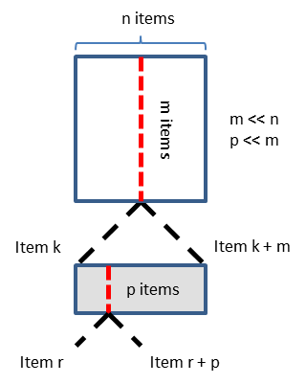
* Click slightly above the letter J in the top slider and notice how the thumb jumps to the position your mouse was in.
* Now please drag the red triangle. Notice how this changes the queried actor/actress/director. Also notice that dragging this is bound by the edges of the slider (can only see items k to k+m by dragging)
* Now roll the mouse wheel. Notice how once you reach the end of the slider and keep going you can continue scrolling.
* P is restricted to a maximum of 1 in this case. This means there can be a **maximum** of two items per pixel in the slider.

ActiveListSlider

* Click slightly above the letter J in the top slider and notice how the thumb jumps to the position your mouse was in.
* Notice the list. This list enumerates items r through r+p. The list tries to show a minimum of 5 items and will never show more than 7 items. If p < 5 then the list will show items beyond r+p.
* Now please drag the red triangle. Notice how this changes the queried actor/actress/director and changes the contents of the list. Also notice that dragging this is bound by the edges of the slider (can only see items k to k+m by dragging). When the red slider approaches the right edge of the main slider notice how the size of the list shrinks.
* Now roll the mouse wheel. Notice how once you reach the end of the slider and keep going you can continue scrolling. This also updates the contents of the list.
* P is restricted to a maximum of 6 in this case. This means there can be a **maximum** of 7 items per pixel in the slider.

The Actor slider encodes ~20 000 items

The Actress slider encodes ~12 000 items

The Director slider encodes ~1 500 items